YUVA INTERN | WEEK 3 TASK
Statistical Analysis and Hypothesis Testing in Python
Does a redesigned checkout page improve user experience and sales? An A/B test evaluated with t-tests, chi-square tests and ANOVA

1. Introduction
E-commerce companies continuously redesign their websites, but a redesign is only valuable if it measurably improves what customers do. Gut feeling and a few good-looking dashboards are not enough: random variation alone can make one version of a page look better than another. Hypothesis testing gives a disciplined way to decide whether an observed difference is large enough to be real, or small enough to be explained by chance.
This report studies a realistic business problem: an online store has launched a redesigned, simplified checkout page (the "New" design) and wants to know whether it should replace the existing page (the "Old" design). Using a controlled A/B experiment, I test four formal hypotheses about checkout speed, conversion rate, device effects and customer-segment spending. Every test is carried out in Python with SciPy, assumptions are checked before each test, effect sizes and confidence intervals are reported alongside p-values, and results are interpreted in business terms.

1.1 Objectives
- Formulate clear, testable null and alternative hypotheses with real-world relevance.
- Design an appropriate statistical methodology for each hypothesis and verify its assumptions.
- Execute the analysis in Python (SciPy, pandas) and interpret p-values and confidence intervals correctly.
- Communicate the findings with visualisations and a discussion of validity, limitations and recommendations.

2. Hypothesis Formulation
The overall research question is: "Does the new checkout design improve the shopping experience and sales compared with the old design, and which factors influence purchase behaviour?" It is broken into four testable hypotheses. The significance level for all tests is α = 0.05.
# | Null hypothesis (H0) | Alternative hypothesis (H1) | Test
H1 | Mean checkout time is the same for New and Old designs (μ_New = μ_Old). | New design has a lower mean checkout time (μ_New < μ_Old). | Welch two-sample t-test (one-tailed)
H2 | Conversion rate is the same for both designs (p_New = p_Old). | New design has a higher conversion rate (p_New > p_Old). | Chi-square / two-proportion z-test
H3 | Conversion and device type are independent. | Conversion rate depends on device type. | Chi-square test of independence
H4 | Mean order value is equal across Customer segments (New, Returning, Loyal). | At least one segment has a different mean order value. | One-way ANOVA + Tukey HSD

H1 and H2 are directional (one-tailed) because the business only cares whether the new design is better; the redesign was motivated by removing steps from checkout. H3 and H4 are exploratory and therefore two-sided.

3. Methodology and Data

3.1 Study design
The study is a two-arm randomised A/B test. Each visitor session is randomly assigned to one design, so any systematic difference in outcomes can be attributed to the design rather than to who happened to see it. Each arm contains 1,200 sessions (2,400 in total), which was chosen so that a conversion lift from 12% to 15% could be detected with reasonable power (see Section 6).

3.2 Dataset
A publicly available dataset with all the required variables was not used; instead I generated a reproducible, self-generated dataset (NumPy random seed = 42) that mimics a real e-commerce experiment. The data are synthetic, so conclusions describe the statistical method and the simulated setting rather than any real company. The dataset has been exported as ecommerce_ab_test_dataset.csv. It contains 2,400 rows and six variables:
Variable | Type | Description
design | Categorical | Checkout design shown: Old or New
device | Categorical | Mobile (55%), Desktop (35%) or Tablet (10%)
segment | Categorical | Customer segment: New (45%), Returning (35%), Loyal (20%)
checkout_time_sec | Continuous | Seconds taken to complete checkout
converted | Binary | 1 if the session ended in a purchase, else 0
order_value_inr | Continuous | Order value in INR (missing for non-purchasers)

Order value is missing for the 2063 sessions that did not purchase, which is expected: a customer who did not buy has no order. Hence H4 uses only the 337 purchasing sessions. No other variable has missing values.

3.3 Statistical methods and why they were chosen
- Welch t-test (H1): compares two means for a continuous outcome. Welch's version does not assume equal variances, so it is safer than the classic Student t-test. Normality was checked with Shapiro–Wilk and variance equality with Levene's test; the Mann–Whitney U test is a non-parametric cross-check.
- Chi-square test (H2, H3): compares categorical outcomes. For two groups it is equivalent to the two-proportion z-test. Expected cell counts must be at least 5, which was verified.
- One-way ANOVA (H4): compares means of more than two groups at once, avoiding the inflated Type I error that repeated t-tests would cause. Tukey HSD then identifies which pairs differ. Order values are right-skewed, so the analysis is done on log-transformed values, with Kruskal–Wallis as a non-parametric check.
- Effect sizes and confidence intervals: Cohen's d (H1), Cramér's V and the 95% CI for the difference in proportions (H2, H3) and eta-squared (H4). A small p-value alone says an effect exists, not whether it is large enough to matter.

3.4 Data generation code
import numpy as np, pandas as pd
from scipy import stats
np.random.seed(42)
n_per_group = 1200; n = 2 * n_per_group
design = np.array(['Old']*n_per_group + ['New']*n_per_group)
device = np.random.choice(['Mobile','Desktop','Tablet'], size=n, p=[0.55,0.35,0.10])
segment = np.random.choice(['New','Returning','Loyal'], size=n, p=[0.45,0.35,0.20])
checkout_time = np.where(design=='Old', np.random.normal(142,28,n),
np.random.normal(136,28,n)).clip(30)
base = np.where(design=='Old', 0.120, 0.150)
p_conv = base + dev_adj # dev_adj: Mobile -0.02, Desktop +0.03, Tablet 0
converted = (np.random.rand(n) < p_conv).astype(int)
# order value ~ lognormal, mean depends on segment (only observed if converted)

4. Exploratory Data Analysis
Before testing, the groups were described. The two designs look similar in structure, and the new design shows a lower average checkout time and a higher conversion rate in the raw data; the tests below check whether these gaps are statistically credible.
Design | Sessions | Mean time (s) | Std dev (s) | Median (s) | Purchases | Conversion
Old | 1200 | 140.44 | 27.64 | 141.20 | 139 | 11.6%
New | 1200 | 136.30 | 29.18 | 135.70 | 198 | 16.5%

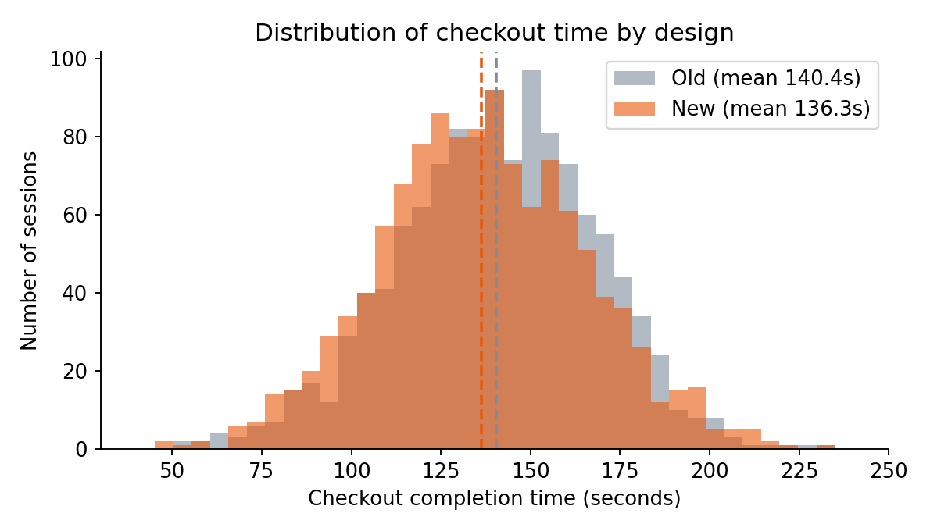
Figure 1: Distribution of checkout time by design
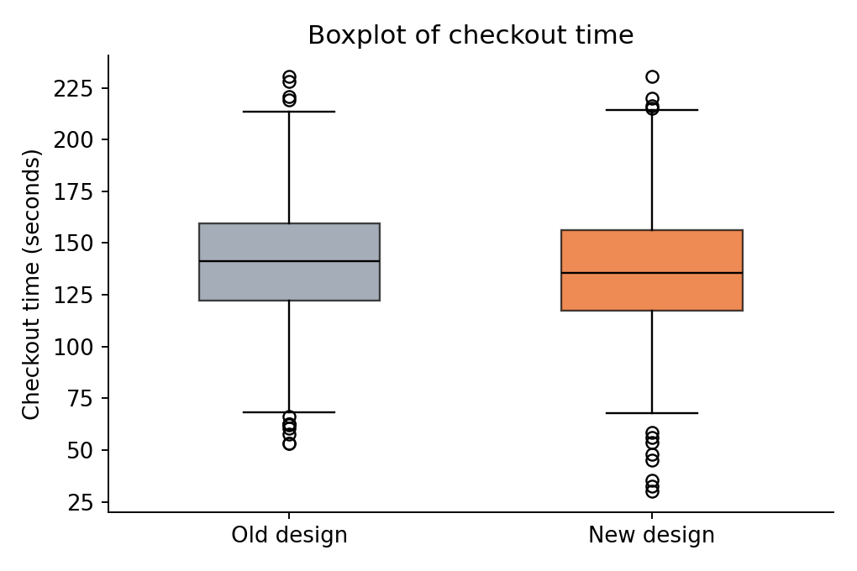
Figure 2: Boxplot of checkout time by design
Both histograms are roughly bell-shaped with similar spread, and the New design is shifted slightly to the left (faster). The boxplots show similar variability and no extreme outliers, which supports using a t-test.

5. Hypothesis Tests and Results

5.1 H1: Checkout time (Welch t-test)
Assumption checks: Shapiro–Wilk on a random sample of 500 sessions per group gave p = 0.418 (Old) and p = 0.158 (New); neither rejects normality (with n = 1,200 per group the central limit theorem also makes the t-test robust). Levene's test gave p = 0.145, so equal variances are plausible, although Welch's test was used anyway for safety.
old_t = df.loc[df.design=='Old','checkout_time_sec']
new_t = df.loc[df.design=='New','checkout_time_sec']
stats.shapiro(old_t.sample(500, random_state=1)) # normality
stats.levene(old_t, new_t) # equal variance
tt = stats.ttest_ind(new_t, old_t, equal_var=False, alternative='less') # Welch
diff = new_t.mean() - old_t.mean()
cohen_d = diff / np.sqrt((new_t.var(ddof=1) + old_t.var(ddof=1)) / 2)
stats.mannwhitneyu(new_t, old_t, alternative='less') # robustness check

Statistic | Value
Mean difference (New − Old) | -4.14 seconds
Welch t-statistic (df = 2391) | -3.569
One-tailed p-value | p < 0.001
95% CI for the difference | [-6.42, -1.87] seconds
Cohen's d | -0.146 (small)
Mann–Whitney U (one-tailed) | U = 653119, p < 0.001

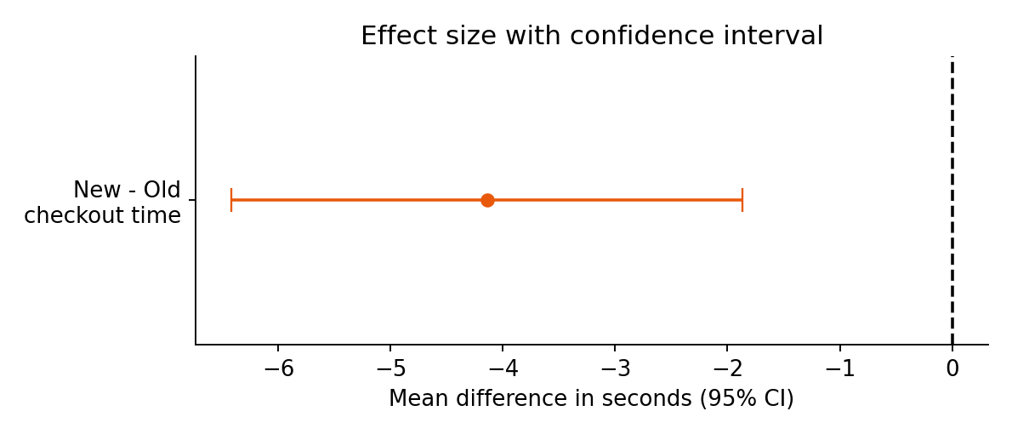
Figure 3: Mean difference in checkout time with 95% confidence interval
Interpretation. Since p < 0.001 is below α = 0.05, H0 is rejected: the new design has a statistically significantly shorter checkout time. Customers finish about 4.1 seconds faster, and we are 95% confident the true reduction lies between 1.9 and 6.4 seconds. The confidence interval does not contain 0, which agrees with the test. However, Cohen's d = 0.15 is a small effect, so the improvement is real but modest in practical terms. The non-parametric Mann–Whitney test reaches the same conclusion, so the result does not depend on the normality assumption.

5.2 H2: Conversion rate by design (chi-square / two-proportion test)
The 2×2 table of design versus purchase is below. All expected counts exceed 5 (smallest = 168.5), so the chi-square approximation is valid.
ct = pd.crosstab(df.design, df.converted).loc[['Old','New'], [0,1]]
chi2, p, dof, expected = stats.chi2_contingency(ct, correction=False)
diff_p = p_new - p_old
se_p = np.sqrt(p_new*(1-p_new)/1200 + p_old*(1-p_old)/1200)
ci_p = (diff_p - 1.96*se_p, diff_p + 1.96*se_p)
cramers_v = np.sqrt(chi2 / n)

Design | No purchase | Purchase | Conversion rate
Old | 1061 | 139 | 11.58%
New | 1002 | 198 | 16.50%

Statistic | Value
Chi-square (df = 1) | 12.017
Two-sided p-value (chi-square) | p < 0.001
z-statistic / one-sided p-value (New > Old) | 3.467 / p < 0.001
Difference in conversion (New − Old) | 4.92 percentage points
95% CI for the difference | [2.14, 7.69] percentage points
Relative lift | 42.4%
Cramér's V | 0.071

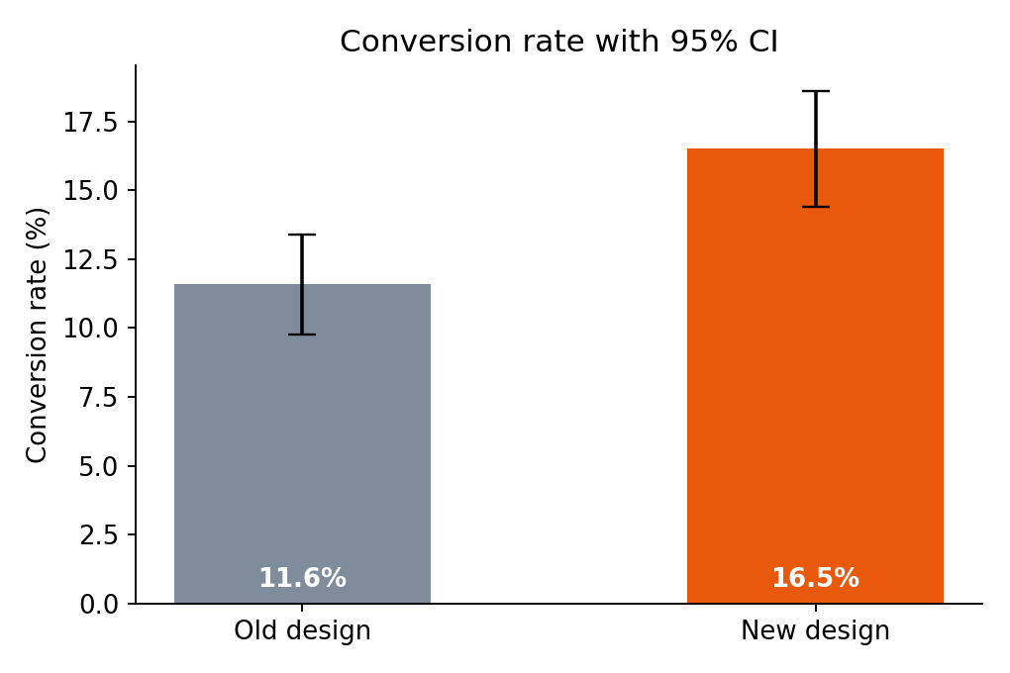
Figure 4: Conversion rate with 95% confidence intervals
Interpretation. The new design converts 16.5% of sessions versus 11.6% for the old one. The one-sided test gives p < 0.001, so H0 is rejected and we conclude that the new design increases conversion. The 95% CI for the lift (2.1 to 7.7 percentage points) excludes zero, and the relative lift of about 42% is commercially meaningful. Cramér's V is small (0.07), which is typical for conversion experiments where most visitors never buy; but small differences in conversion are multiplied across thousands of visitors.

5.3 H3: Conversion and device type (chi-square test of independence)
ct2 = pd.crosstab(df.device, df.converted).loc[['Mobile','Desktop','Tablet'], [0,1]]
chi2b, pb, dofb, expb = stats.chi2_contingency(ct2)

Device | No purchase | Purchase | Conversion rate
Mobile | 1162 | 147 | 11.2%
Desktop | 703 | 156 | 18.2%
Tablet | 198 | 34 | 14.7%

Result: χ²(2) = 20.721, p < 0.001, Cramér's V = 0.093. The smallest expected count is 32.6, so the test is valid.
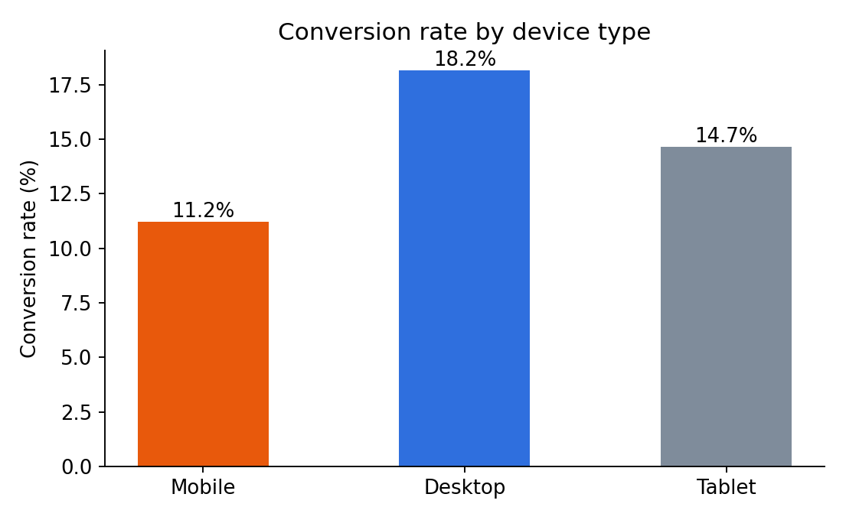
Figure 5: Conversion rate by device type
Interpretation. Because p < 0.05, H0 (independence) is rejected: the probability of buying depends on the device used. Desktop users convert most (18.2%) and mobile users least (11.2%). The effect is small (V = 0.09) but it points to a business opportunity, since mobile makes up more than half of all traffic. A significant chi-square test says that some difference exists; it does not say which devices differ, so further pairwise comparisons would be needed before targeting any one device.

5.4 H4: Order value across customer segments (one-way ANOVA)
Order values are right-skewed: a Shapiro–Wilk test on the raw values rejects normality (p < 0.001), as the left Q–Q plot below shows. After a log transformation the data look normal (Shapiro–Wilk p = 0.3210 ≈ 0.32) and Levene's test supports equal variances (p = 0.90). ANOVA was therefore run on log order value.
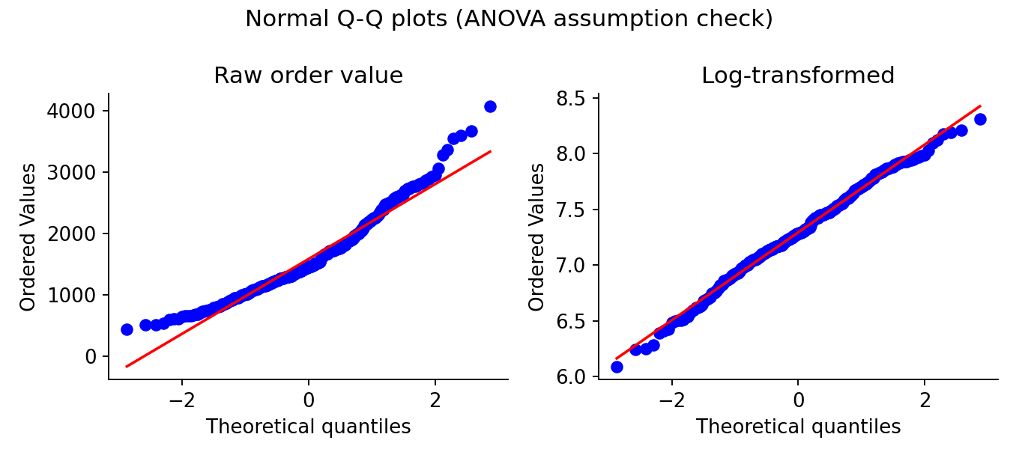
Figure 6: Q–Q plots before and after log transformation
buyers = df.dropna(subset=['order_value_inr']).copy()
buyers['log_ov'] = np.log(buyers.order_value_inr)
groups = [buyers.loc[buyers.segment==s,'log_ov'] for s in ['New','Returning','Loyal']]
stats.shapiro(buyers.log_ov); stats.levene(*groups)
F, p_f = stats.f_oneway(*groups)
eta2 = ssb / sst # effect size (SS_between / SS_total)
stats.kruskal(*groups_raw) # non-parametric check
tuk = stats.tukey_hsd(*groups) # post-hoc pairwise comparisons

Segment | Buyers | Mean (INR) | Std dev | Median
New | 154 | 1416 | 546 | 1330
Returning | 121 | 1714 | 651 | 1527
Loyal | 62 | 1753 | 638 | 1683

Statistic | Value
ANOVA F(2, 334) | 12.436
p-value | p < 0.001
Eta-squared (η²) | 0.069 (medium)
Kruskal–Wallis H | 19.59, p < 0.001

Tukey HSD post-hoc comparisons (on log scale):
Pair | Mean log difference | Adjusted p | Significant (α=0.05)?
New vs Returning | -0.197 | < 0.001 | Yes
New vs Loyal | -0.224 | < 0.001 | Yes
Returning vs Loyal | -0.027 | 0.889 | No

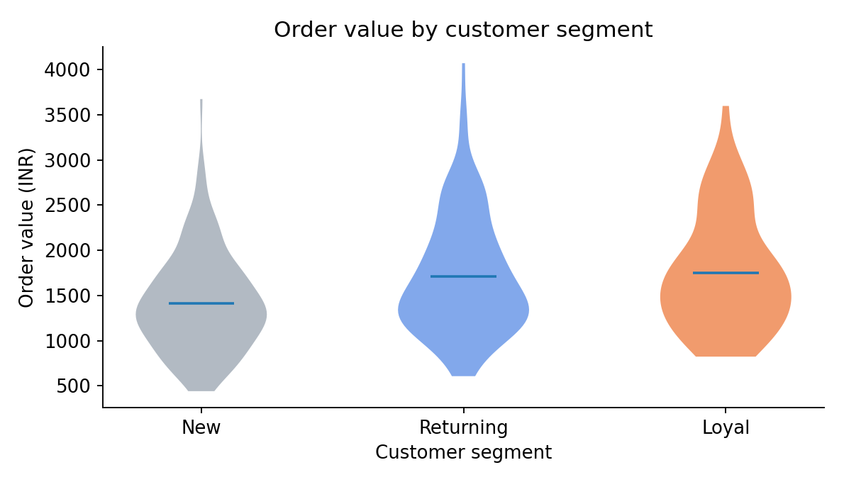
Figure 7: Order value by customer segment
Interpretation. The ANOVA is significant (p < 0.001), so H0 is rejected: average order value is not the same in all segments. Tukey's test shows that New customers spend significantly less than both Returning and Loyal customers, while Returning and Loyal customers do not differ significantly from each other (p = 0.89). Segment explains about 6.9% of the variation in log order value, a medium effect. The Kruskal–Wallis test, which makes no normality assumption, agrees. The practical message is that the largest gain in spending occurs when a first-time customer becomes a repeat customer; that is where retention efforts have the biggest payoff.

6. Power Analysis and Multiple Testing
Statistical power is the probability of detecting an effect that truly exists. For the conversion test, with 1,200 sessions per group, the study had about 58% power to detect the planned lift from 12% to 15%, which is below the conventional 80% target; the power at the lift actually observed (11.6% to 16.5%) is 93%. In a real experiment, a pre-study power calculation would have called for roughly 2,000 sessions per group to reach 80% power for a 3 percentage-point lift. The significant result here is not undermined by this, but a non-significant result would have been inconclusive.
Four hypotheses were tested at α = 0.05, which raises the chance of at least one false positive. With a Bonferroni correction the threshold becomes 0.05 / 4 = 0.0125. All four p-values are below 0.001, so they remain below this stricter threshold, so the conclusions are robust to multiple-testing correction.

7. Discussion and Conclusions

7.1 Summary of findings
Hypothesis | Test | Result | Decision
H1: New design is faster | Welch t-test | t = -3.57, p < 0.001; −4.1 s | Reject H0
H2: New design converts more | Chi-square / z-test | χ² = 12.02, p < 0.001; +4.9 pp | Reject H0
H3: Conversion depends on device | Chi-square independence | χ² = 20.72, p < 0.001 | Reject H0
H4: Order value differs by segment | One-way ANOVA | F = 12.44, p < 0.001 | Reject H0

7.2 Validity of the hypotheses and business implications
The evidence supports the central hypothesis that the redesigned checkout improves the customer experience: it is quicker to complete and leads to more purchases. The conversion improvement is the most valuable result, with a relative lift of about 42%. The speed gain is statistically reliable but small. The secondary findings suggest where to focus next: mobile conversion is the weakest, and first-time customers spend much less than repeat customers.
Recommendation: roll out the new checkout design to all users, monitor conversion by device after launch, and invest in mobile optimisation and in converting first-time buyers into repeat customers.

7.3 Limitations
- Synthetic data. The dataset was generated by simulation, with effects built in by design. Real data would be messier (bots, returning users counted twice, seasonality), and the results show how the methods work rather than a real-world discovery.
- Statistical versus practical significance. With large samples even tiny differences become "significant", which is why effect sizes and confidence intervals were reported.
- Correlation inside segments. H3 and H4 are observational comparisons across device and segment, so they describe association, not causation.
- Short horizon. An A/B test run over a short window may capture novelty effects; a longer follow-up would be needed to confirm the lift persists.
- Simplifying assumptions. Sessions are treated as independent; in reality the same user may appear in several sessions.

7.4 Final remarks
This project applied the full workflow of statistical inference: forming hypotheses, checking assumptions, choosing appropriate tests, quantifying effect size with confidence intervals, validating with non-parametric alternatives, and communicating the findings in business language. Choosing the test to fit the data type and the assumptions, and not just reading off a p-value, is what makes the conclusions trustworthy.

Appendix A: Complete Python Code
The script below generates the dataset, runs all tests, saves the figures and prints the results. It requires only pandas, NumPy, SciPy and Matplotlib.
import json
import numpy as np
import pandas as pd
import matplotlib
matplotlib.use("Agg")
import matplotlib.pyplot as plt
from scipy import stats

np.random.seed(42)
ALPHA = 0.05
R = {} # results store

# ------------------------------------------------------------------
# 1. DATASET GENERATION (self-generated, reproducible with seed 42)
# ------------------------------------------------------------------
n_per_group = 1200
n = 2 * n_per_group
design = np.array(["Old"] * n_per_group + ["New"] * n_per_group)
device = np.random.choice(["Mobile", "Desktop", "Tablet"], size=n, p=[0.55, 0.35, 0.10])
segment = np.random.choice(["New", "Returning", "Loyal"], size=n, p=[0.45, 0.35, 0.20])

# Checkout time (seconds): new design is faster by ~6 s on average
checkout_time = np.where(design == "Old",
np.random.normal(142, 28, n),
np.random.normal(136, 28, n)).clip(30)

# Conversion probability depends on design and device
base = np.where(design == "Old", 0.120, 0.150)
dev_adj = np.select([device == "Mobile", device == "Desktop", device == "Tablet"],
[-0.020, 0.030, 0.000])
p_conv = base + dev_adj
converted = (np.random.rand(n) < p_conv).astype(int)

# Order value (INR) depends on customer segment (only meaningful if converted)
seg_mean = {"New": 1450, "Returning": 1620, "Loyal": 1830}
order_value = np.array([np.random.lognormal(np.log(seg_mean[s]) - 0.08, 0.40) for s in segment])
order_value = np.where(converted == 1, order_value, np.nan)

df = pd.DataFrame({"design": design, "device": device, "segment": segment,
"checkout_time_sec": checkout_time.round(1),
"converted": converted, "order_value_inr": order_value.round(0)})
df.to_csv("ecommerce_ab_test_dataset.csv", index=False)
R["n_total"] = n
R["head"] = df.head(8).to_dict(orient="records")
R["desc_time"] = df.groupby("design")["checkout_time_sec"].agg(["count", "mean", "std", "median"]).round(2).to_dict("index")
R["conv_rate"] = df.groupby("design")["converted"].agg(["sum", "count", "mean"]).round(4).to_dict("index")
R["missing"] = {k: int(v) for k, v in df.isna().sum().items()}

# ------------------------------------------------------------------
# TEST 1: Welch two-sample t-test (checkout time New vs Old)
# ------------------------------------------------------------------
old_t = df.loc[df.design == "Old", "checkout_time_sec"]
new_t = df.loc[df.design == "New", "checkout_time_sec"]
sw_old = stats.shapiro(old_t.sample(500, random_state=1))
sw_new = stats.shapiro(new_t.sample(500, random_state=1))
lev = stats.levene(old_t, new_t)
tt = stats.ttest_ind(new_t, old_t, equal_var=False, alternative="less")
diff = new_t.mean() - old_t.mean()
se = np.sqrt(new_t.var(ddof=1) / len(new_t) + old_t.var(ddof=1) / len(old_t))
dfw = se**4 / ((new_t.var(ddof=1) / len(new_t))**2 / (len(new_t) - 1) + (old_t.var(ddof=1) / len(old_t))**2 / (len(old_t) - 1))
tcrit = stats.t.ppf(0.975, dfw)
ci_t = (diff - tcrit * se, diff + tcrit * se)
sp = np.sqrt((new_t.var(ddof=1) + old_t.var(ddof=1)) / 2)
cohen_d = diff / sp
mw = stats.mannwhitneyu(new_t, old_t, alternative="less")
R["t1"] = dict(shapiro_old_p=sw_old.pvalue, shapiro_new_p=sw_new.pvalue, levene_p=lev.pvalue,
t=tt.statistic, p=tt.pvalue, df=dfw, diff=diff, ci_low=ci_t[0], ci_high=ci_t[1],
d=cohen_d, mw_U=mw.statistic, mw_p=mw.pvalue)

# ------------------------------------------------------------------
# TEST 2: Two-proportion chi-square test (conversion New vs Old)
# ------------------------------------------------------------------
ct = pd.crosstab(df.design, df.converted).loc[["Old", "New"], [0, 1]]
chi2, p_chi, dof, exp = stats.chi2_contingency(ct, correction=False)
x_new, x_old = ct.loc["New", 1], ct.loc["Old", 1]
p_new, p_old = x_new / n_per_group, x_old / n_per_group
diff_p = p_new - p_old
se_p = np.sqrt(p_new * (1 - p_new) / n_per_group + p_old * (1 - p_old) / n_per_group)
ci_p = (diff_p - 1.96 * se_p, diff_p + 1.96 * se_p)
p_pool = (x_new + x_old) / n
z = diff_p / np.sqrt(p_pool * (1 - p_pool) * (2 / n_per_group))
p_one = 1 - stats.norm.cdf(z) # one-sided (New > Old)
cramers_v = np.sqrt(chi2 / n)
R["t2"] = dict(table=ct.values.tolist(), chi2=chi2, p_two=p_chi, dof=int(dof), z=z, p_one=p_one,
p_new=p_new, p_old=p_old, diff=diff_p, ci_low=ci_p[0], ci_high=ci_p[1],
rel_lift=diff_p / p_old, v=cramers_v, min_expected=float(exp.min()))

# ------------------------------------------------------------------
# TEST 3: Chi-square test of independence (conversion vs device)
# ------------------------------------------------------------------
ct2 = pd.crosstab(df.device, df.converted).loc[["Mobile", "Desktop", "Tablet"], [0, 1]]
chi2b, pb, dofb, expb = stats.chi2_contingency(ct2)
R["t3"] = dict(table=ct2.values.tolist(), chi2=chi2b, p=pb, dof=int(dofb), v=np.sqrt(chi2b / n),
min_expected=float(expb.min()),
rates=(ct2[1] / ct2.sum(axis=1)).round(4).to_dict())

# ------------------------------------------------------------------
# TEST 4: One-way ANOVA (order value across customer segments)
# ------------------------------------------------------------------
buyers = df.dropna(subset=["order_value_inr"]).copy()
buyers["log_ov"] = np.log(buyers.order_value_inr)
groups = [buyers.loc[buyers.segment == s, "log_ov"] for s in ["New", "Returning", "Loyal"]]
groups_raw = [buyers.loc[buyers.segment == s, "order_value_inr"] for s in ["New", "Returning", "Loyal"]]
sw_raw = stats.shapiro(buyers.order_value_inr)
sw_log = stats.shapiro(buyers.log_ov)
lev_a = stats.levene(*groups)
F, p_f = stats.f_oneway(*groups)
k = 3
N = len(buyers)
grand = buyers.log_ov.mean()
ssb = sum(len(g) * (g.mean() - grand) ** 2 for g in groups)
sst = ((buyers.log_ov - grand) ** 2).sum()
eta2 = ssb / sst
kw = stats.kruskal(*groups_raw)
tuk = stats.tukey_hsd(*groups)
names = ["New", "Returning", "Loyal"]
pairs = []
for i, j in [(0, 1), (0, 2), (1, 2)]:
ci = tuk.confidence_interval()
pairs.append(dict(pair=f"{names[i]} vs {names[j]}", mean_diff=float(groups[i].mean() - groups[j].mean()),
p=float(tuk.pvalue[i][j])))
R["t4"] = dict(n_buyers=int(N), shapiro_raw_p=sw_raw.pvalue, shapiro_log_p=sw_log.pvalue,
levene_p=lev_a.pvalue, F=F, p=p_f, df_between=k - 1, df_within=int(N - k),
eta2=eta2, kw_H=kw.statistic, kw_p=kw.pvalue, tukey=pairs,
seg_stats=buyers.groupby("segment")["order_value_inr"].agg(["count", "mean", "std", "median"]).round(1).loc[names].to_dict("index"))

# ------------------------------------------------------------------
# Power analysis for the conversion test (normal approximation)
# ------------------------------------------------------------------
def power_two_prop(p1, p2, n_each, alpha=0.05):
pbar = (p1 + p2) / 2
se0 = np.sqrt(2 * pbar * (1 - pbar) / n_each)
se1 = np.sqrt(p1 * (1 - p1) / n_each + p2 * (1 - p2) / n_each)
zc = stats.norm.ppf(1 - alpha / 2)
return 1 - stats.norm.cdf((zc * se0 - abs(p2 - p1)) / se1)

R["power"] = dict(n=n_per_group, power_at_obs=power_two_prop(p_old, p_new, n_per_group),
power_planned=power_two_prop(0.12, 0.15, n_per_group))

# ------------------------------------------------------------------
# VISUALISATIONS
# ------------------------------------------------------------------
plt.rcParams.update({"font.size": 11, "axes.spines.top": False, "axes.spines.right": False})
C_OLD, C_NEW = "#7F8C9B", "#E8590C"

# Fig 1: histogram + KDE-like overlay of checkout time
fig, ax = plt.subplots(figsize=(7, 4))
bins = np.linspace(40, 240, 40)
ax.hist(old_t, bins=bins, alpha=0.6, color=C_OLD, label=f"Old (mean {old_t.mean():.1f}s)")
ax.hist(new_t, bins=bins, alpha=0.6, color=C_NEW, label=f"New (mean {new_t.mean():.1f}s)")
ax.axvline(old_t.mean(), color=C_OLD, ls="--"); ax.axvline(new_t.mean(), color=C_NEW, ls="--")
ax.set_xlabel("Checkout completion time (seconds)"); ax.set_ylabel("Number of sessions")
ax.set_title("Distribution of checkout time by design"); ax.legend()
plt.tight_layout(); plt.savefig("fig1_hist_time.png", dpi=170); plt.close()

# Fig 2: boxplot of checkout time
fig, ax = plt.subplots(figsize=(6, 4))
bp = ax.boxplot([old_t, new_t], tick_labels=["Old design", "New design"], patch_artist=True, widths=0.5)
for patch, c in zip(bp["boxes"], [C_OLD, C_NEW]): patch.set_facecolor(c); patch.set_alpha(0.7)
for m in bp["medians"]: m.set_color("black")
ax.set_ylabel("Checkout time (seconds)"); ax.set_title("Boxplot of checkout time")
plt.tight_layout(); plt.savefig("fig2_box_time.png", dpi=170); plt.close()

# Fig 3: conversion rate with 95% CI
fig, ax = plt.subplots(figsize=(6, 4))
rates = [p_old, p_new]
errs = [1.96 * np.sqrt(p_old * (1 - p_old) / n_per_group), 1.96 * np.sqrt(p_new * (1 - p_new) / n_per_group)]
bars = ax.bar(["Old design", "New design"], [r * 100 for r in rates], yerr=[e * 100 for e in errs],
color=[C_OLD, C_NEW], capsize=6, width=0.5)
for b, r in zip(bars, rates): ax.text(b.get_x() + b.get_width() / 2, 0.6, f"{r*100:.1f}%", ha="center", color="white", fontweight="bold")
ax.set_ylabel("Conversion rate (%)"); ax.set_title("Conversion rate with 95% CI")
plt.tight_layout(); plt.savefig("fig3_conversion.png", dpi=170); plt.close()

# Fig 4: conversion by device
fig, ax = plt.subplots(figsize=(6.5, 4))
dev_rates = (ct2[1] / ct2.sum(axis=1) * 100)
bars = ax.bar(dev_rates.index, dev_rates.values, color=["#E8590C", "#2F6FDE", "#7F8C9B"], width=0.5)
for b, r in zip(bars, dev_rates.values): ax.text(b.get_x() + b.get_width() / 2, r + 0.2, f"{r:.1f}%", ha="center")
ax.set_ylabel("Conversion rate (%)"); ax.set_title("Conversion rate by device type")
plt.tight_layout(); plt.savefig("fig4_device.png", dpi=170); plt.close()

# Fig 5: order value by segment (violin + means)
fig, ax = plt.subplots(figsize=(7, 4))
vp = ax.violinplot(groups_raw, showmeans=True, showextrema=False)
for body, c in zip(vp["bodies"], ["#7F8C9B", "#2F6FDE", "#E8590C"]): body.set_facecolor(c); body.set_alpha(0.6)
ax.set_xticks([1, 2, 3]); ax.set_xticklabels(names)
ax.set_ylabel("Order value (INR)"); ax.set_xlabel("Customer segment")
ax.set_title("Order value by customer segment")
plt.tight_layout(); plt.savefig("fig5_violin_segment.png", dpi=170); plt.close()

# Fig 6: Q-Q plot for ANOVA residual check (log scale)
fig, axs = plt.subplots(1, 2, figsize=(8, 3.6))
stats.probplot(buyers.order_value_inr, dist="norm", plot=axs[0]); axs[0].set_title("Raw order value")
stats.probplot(buyers.log_ov, dist="norm", plot=axs[1]); axs[1].set_title("Log-transformed")
fig.suptitle("Normal Q-Q plots (ANOVA assumption check)")
plt.tight_layout(); plt.savefig("fig6_qq.png", dpi=170); plt.close()

# Fig 7: mean difference with CI forest-style summary
fig, ax = plt.subplots(figsize=(7, 3))
ax.errorbar(diff, 1, xerr=[[diff - ci_t[0]], [ci_t[1] - diff]], fmt="o", color=C_NEW, capsize=6)
ax.axvline(0, color="black", ls="--"); ax.set_yticks([1]); ax.set_yticklabels(["New - Old\ncheckout time"])
ax.set_xlabel("Mean difference in seconds (95% CI)"); ax.set_title("Effect size with confidence interval")
plt.tight_layout(); plt.savefig("fig7_ci.png", dpi=170); plt.close()

def clean(o):
if isinstance(o, dict): return {str(k): clean(v) for k, v in o.items()}
if isinstance(o, (list, tuple)): return [clean(v) for v in o]
if isinstance(o, (np.floating, float)): return float(o)
if isinstance(o, (np.integer,)): return int(o)
return o

json.dump(clean(R), open("results.json", "w"), indent=1, default=str)
print(json.dumps(clean(R), indent=1, default=str))

Appendix B: References
- Virtanen, P. et al. (2020). SciPy 1.0: fundamental algorithms for scientific computing in Python. Nature Methods, 17, 261–272.
- Welch, B. L. (1947). The generalization of "Student's" problem when several different population variances are involved. Biometrika, 34, 28–35.
- Cohen, J. (1988). Statistical Power Analysis for the Behavioral Sciences (2nd ed.). Lawrence Erlbaum Associates.
- Tukey, J. W. (1949). Comparing individual means in the analysis of variance. Biometrics, 5(2), 99–114.
- Kohavi, R., Tang, D., & Xu, Y. (2020). Trustworthy Online Controlled Experiments. Cambridge University Press.
- SciPy documentation: scipy.stats module. https://docs.scipy.org/doc/scipy/reference/stats.html

